Project 12-1: Exploring Common Vulnerabilities and Exposures (CVE)
Estimated Time: 25 minutes
Objective: Research CVE.
Description: Vulnerability feeds are available to provide updated information to scanning software about the latest vulnerabilities. One of the most highly regarded is the Common Vulnerabilities and Exposures (CVE). These can also be manually examined for information on the latest vulnerabilities. In this project, you will learn more about CVE and view CVE information.
- Open your web browser and enter the URL https://cve.org/ (If you are no longer able to access the site through this web address, use a search engine to search for “Mitre CVE".)
- Click Resources & Support in the top menu.
- Click FAQs and read through this overview, expanding the items where necessary.
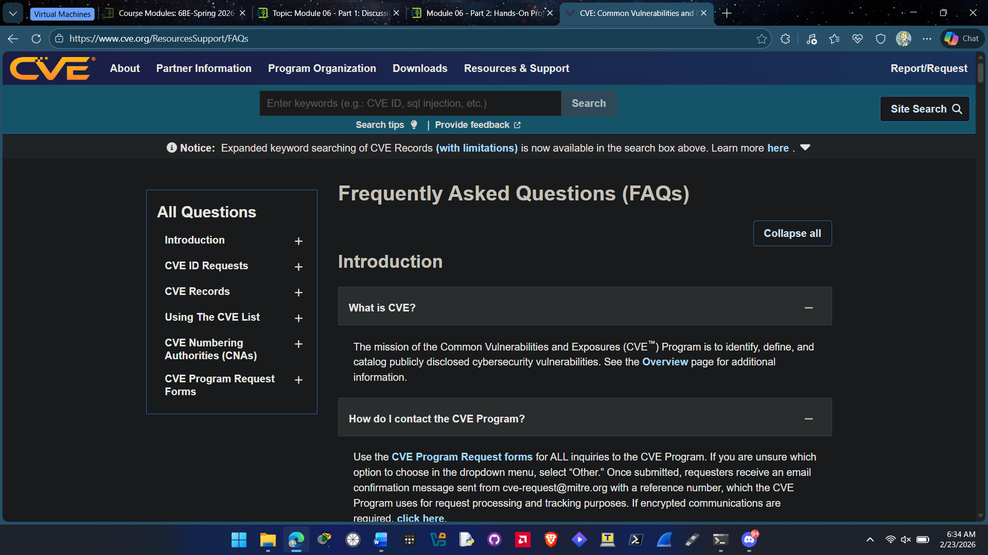

- Click About in the top menu.
- Watch the video CVE Program Overview. In your own words, how would you describe it? How does it work? What advantages does it provide?
THE CVE program is a worldwide effort that assings unizque identifiers to known cybersec vulnerabilities. Each record contains a ID and basic info about vulnerability. This makes it easier for security tools and researchers to keep track and discuss issues about vulnerabilities.

- In the About box, expand Process.
- Click CVE Record Lifecycle.

- Read through the steps and expand items where necessary.
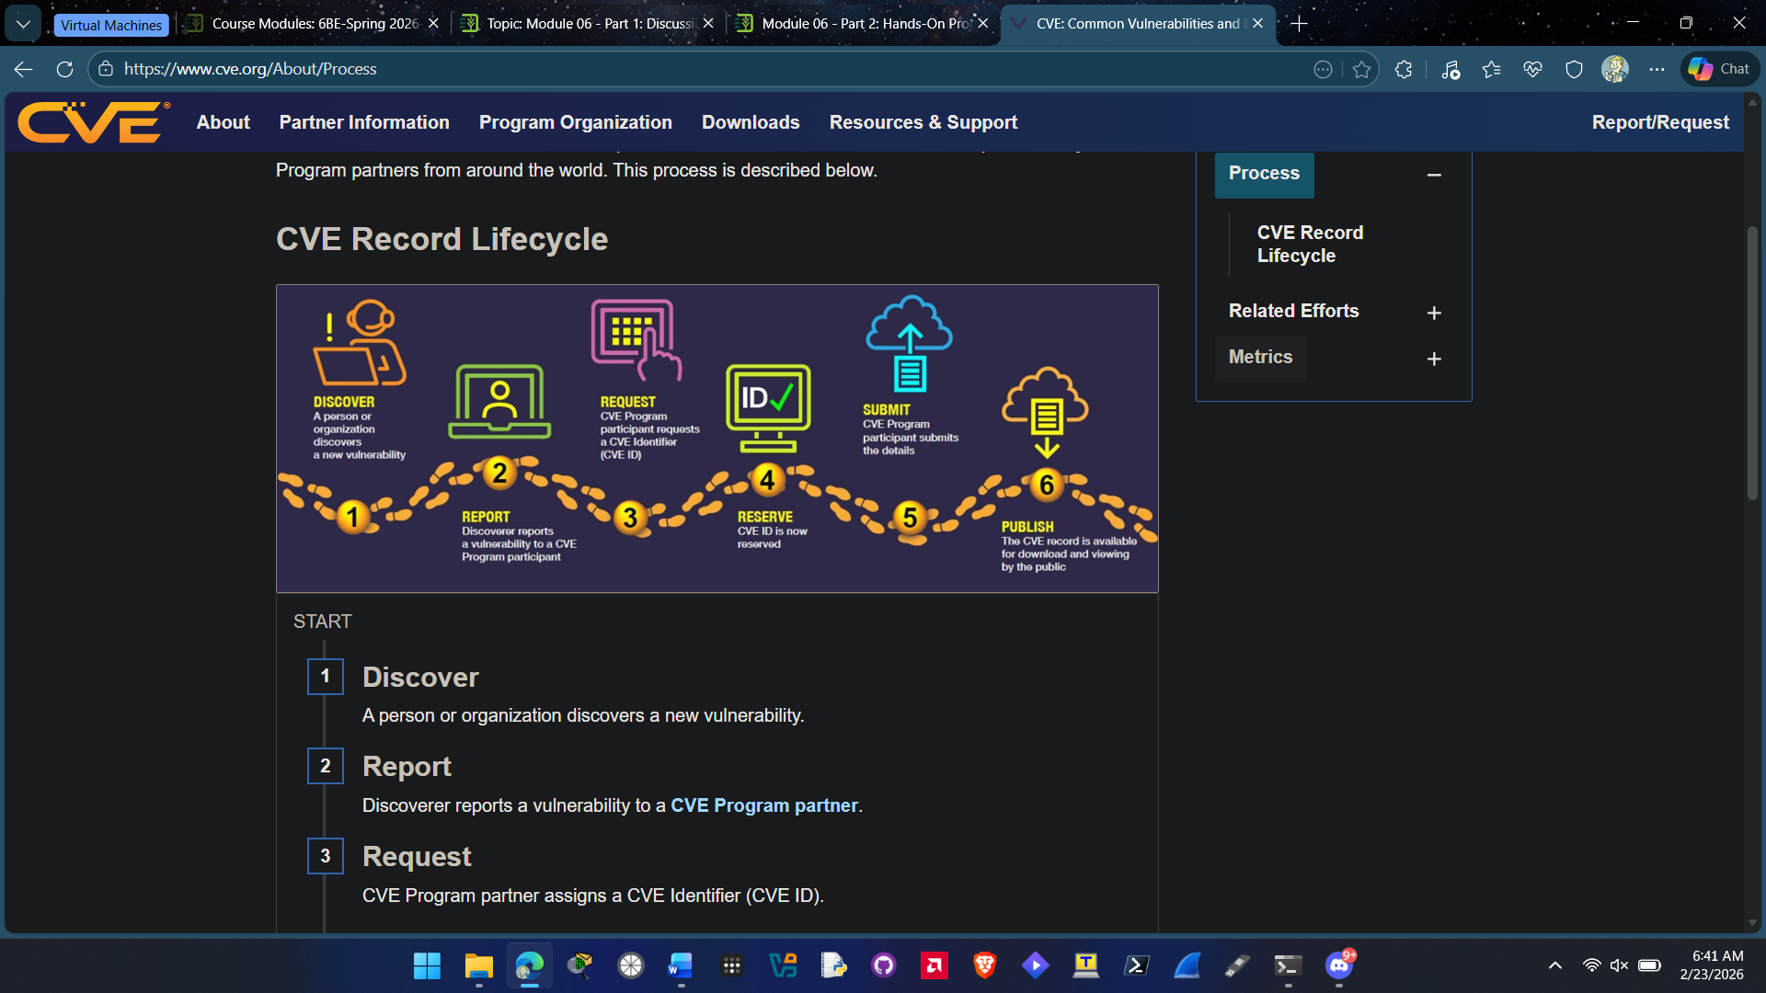
- Searches can be performed through either entering specific CVE IDs or by keyword. Click the breakout icon next to CVE List keyword search.
- Enter a generic vulnerability such as passwords and then click Submit to display the CVE entries. How many relate to this topic?
I entered passwords as by keyword and there is 2,847 search results related to this topic.

- Select several of the CVE entries and read through the material.
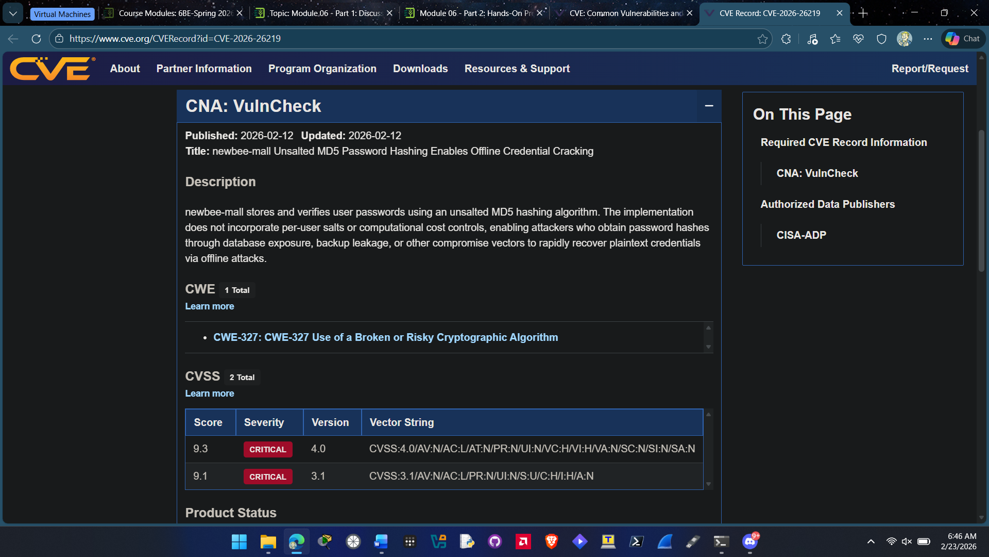
- Locate a CVE entry that contains the tag Disputed. Click this entry. Under Description, click **DISPUTED** to read about what constitutes a disputed CVE. Who would dispute a CVE? Why?
A CVE could be disputed for a couple of reasons. Probably the validity of the vulnerability is one of them or maybe the accuracy of the record and how it documents the vulnerability. This is because there are different threat models which can cause disagreements in general.

- Return to the CVE page with the description of the CVE you selected. Click Search CVE List.
- Enter a different vulnerability and select several entries to read through its details.
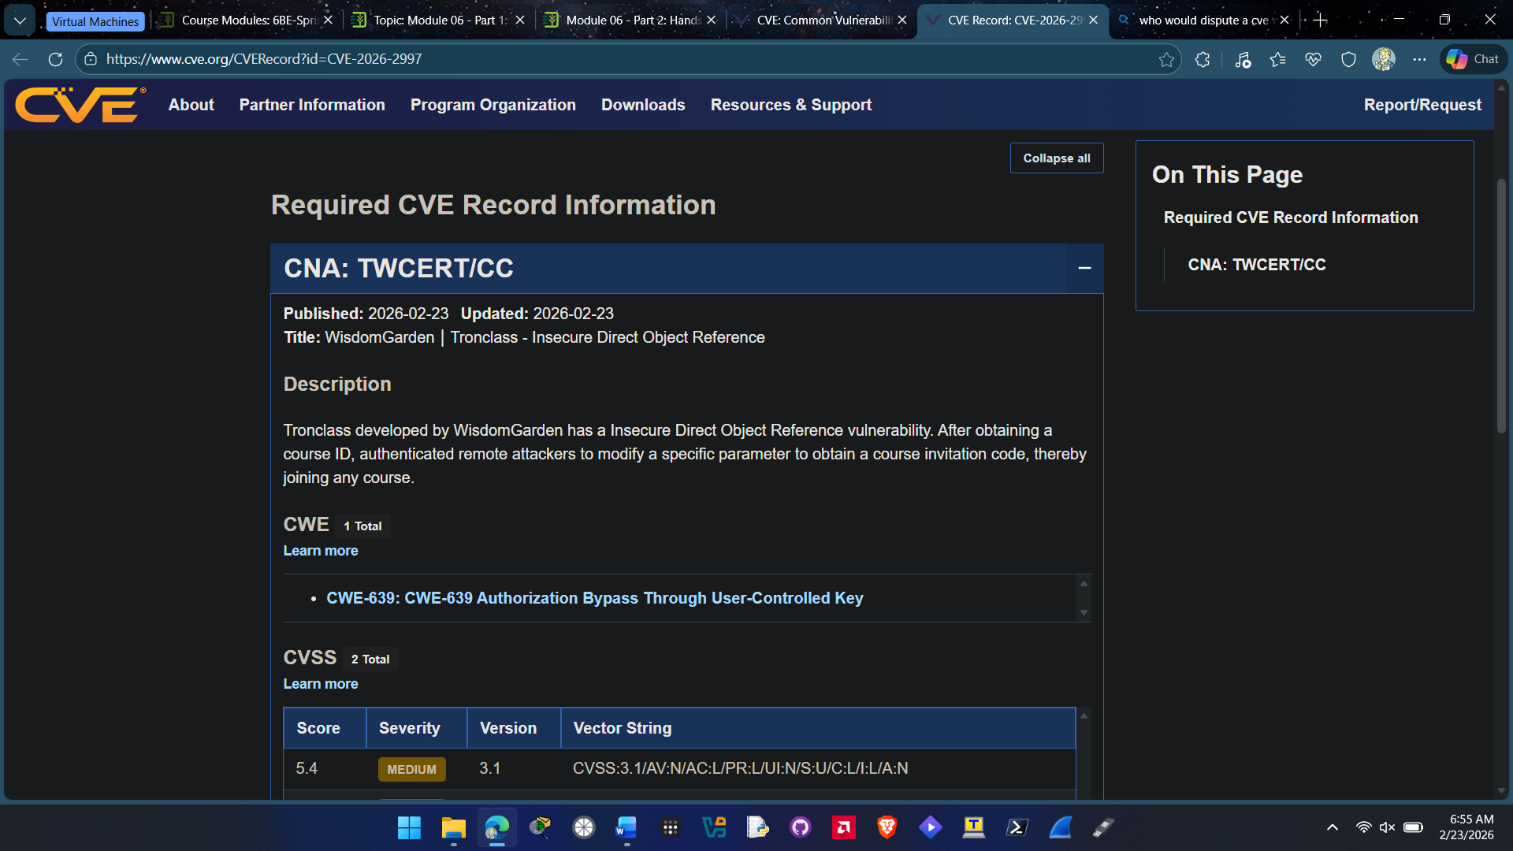
- Close all windows.

Criteria | Meets Requirements | Needs Improvement | Incomplete
Content | The assignment clearly and comprehensively addresses all questions in the assignment.  15 points | The assignment partially addresses some or all questions in the assignment.  8 points | The assignment does not address the questions in the assignment.  0 points
Organization and Clarity | The assignment presents ideas in a clear manner and with strong organizational structure. The assignment includes appropriate content, coverage of facts, arguments, and conclusions.  10 points | The assignment presents ideas in a mostly clear manner and with some organizational structure. The assignment includes appropriate content, coverage of facts, arguments, and conclusions.  7 points | The assignment does not present ideas in a clear manner or with a strong organizational structure. The assignment includes some appropriate content, but coverage of facts, arguments, and conclusions are not logically related and consistent.  0 points
Research | The assignment is based upon appropriate and adequate data collection and analysis of results from the activity or research from academically reliable sources.  5 points | The assignment is based upon adequate data collection and includes some analysis of results from the activity or research from academically reliable sources.  3 points | The assignment is not based upon appropriate data collection and includes no analysis of results from the activity or research from academically reliable sources.  0 points
Grammar and Spelling | The assignment has two or fewer grammatical and spelling errors.  5 points | The assignment has three to five grammatical and spelling errors.  3 points | The assignment has more than five grammatical and spelling errors, is incomplete, or is unintelligible.  0 points

